E-Commerce Application

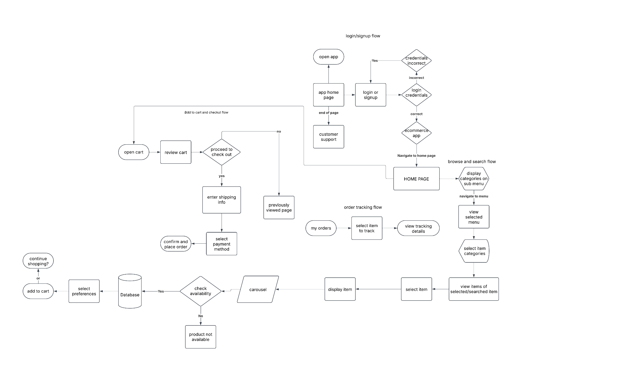

**Task Analysis**

* Starting/opening the app
* Browsing/Searching for Products **using the search feature or categories**
* Adding the item to the Cart
* Plcing the order and checking out

Process Flow

1. Opening the App for Authentication

|  |  |
| --- | --- |
|  | Start: User launches the application. |
|  | Open App: App opens to the welcome screen. |
|  | Sign In/Sign Up: User logs in or creates an account. |
|  | Home Page: If authenticated, the user lands on the home page. |

Flow: Start → Open App → Sign In/Sign Up → Home Page

2.Browsing or Searching for Products

Browsing Products

|  |  |
| --- | --- |
|  | Browse Products: User chooses to browse categories. |
|  | Select a Category: User selects a product category. |
|  | View Product Details: User views detailed information about a product. |
|  | Check Availability: The system checks if the product is in stock. |

Flow: Browse/Search Products → Select a Category → View Product Details → Check Availability

Searching for a Specific Product

|  |  |
| --- | --- |
|  | Search Products: User selects the search option. |
|  | View Product Details: User selects a product to see details. |
|  | Check Availability: The system checks if the product is in stock. |

Flow: Search or Browse → Enter Search Term → Execute Search → View Product Details → Check Availability

1. Adding a Product to the Cart

|  |  |
| --- | --- |
|  | Product Available? System checks if the product is available. |
|  | If No, the system displays "Out of Stock" and the flow stops. |
|  | If Yes, the user selects product options (size, color, quantity). |
|  | Add to Cart: User clicks "Add to Cart". |
|  | Continue Shopping Decision: User decides whether to continue shopping or proceed to checkout. |

Flow: Product Available? → (Yes) → Select Options → Add to Cart → Continue Shopping Decision

1. Checking Out

|  |  |
| --- | --- |
|  | Open Cart: User taps on the cart icon. |
|  | Review Items: User checks all products in the cart. |
|  | Proceed to Checkout: User confirms readiness for payment. |
|  | Enter Shipping/Payment Info: User provides shipping and payment details. |
|  | Select Payment Method: The system confirms the mode of payment. |
|  | End: User closes the app |

Flow: Open Cart → Review Items → Proceed to Checkout → Enter Shipping/Payment Info → Order Confirmed